ADD NEW Doctor to Doctors Page (Pre-Add)

ADD NEW Doctor to Doctors Page (Post-Add)

BROWSE Doctors Page

SEARCH Doctor in Doctors Page (Pre-Search)

SEARCH Doctor in Doctors Page (Post-Search)

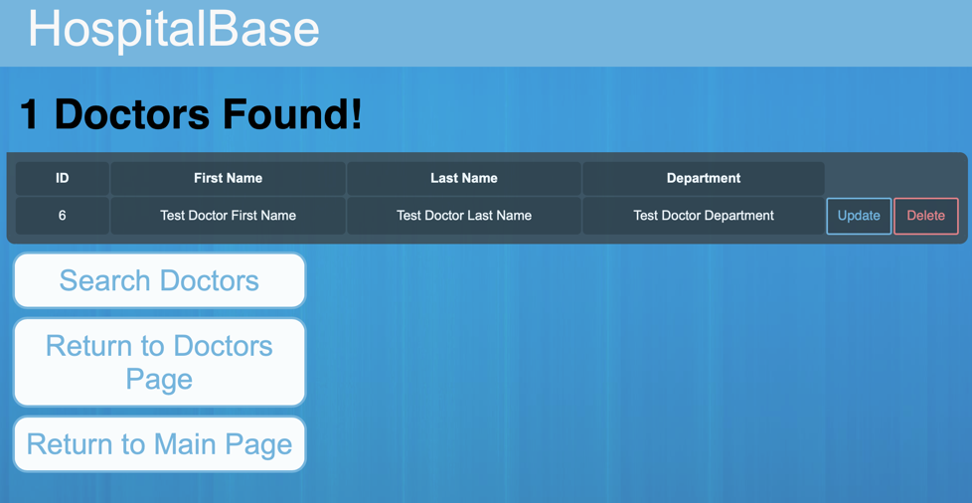

UPDATE Doctor in Doctors Page (Pre-Update)

UPDATE Doctor in Doctors Page (During-Update)

UPDATE Doctor in Doctors Page (Post-Update)

Delete Doctor From Doctors Page

